**Project Development Phase**

**Sprint - II**

|  |  |
| --- | --- |
| **Date** | 23 November 2022 |
| **Team ID** | PNT2022TMID51308 |
| **Project Name** | **Natural Disasters Intensity Analysis And Classification Using Artificial Intelligence** |
| **Maximum Marks** | **4 Marks** |

**Building the CNN Model for Natural Disaster Classification, Training and Validating it, and Testing results**

# 1. Indexing Disaster Classes



# 2. Sample Plot for each of the Classes

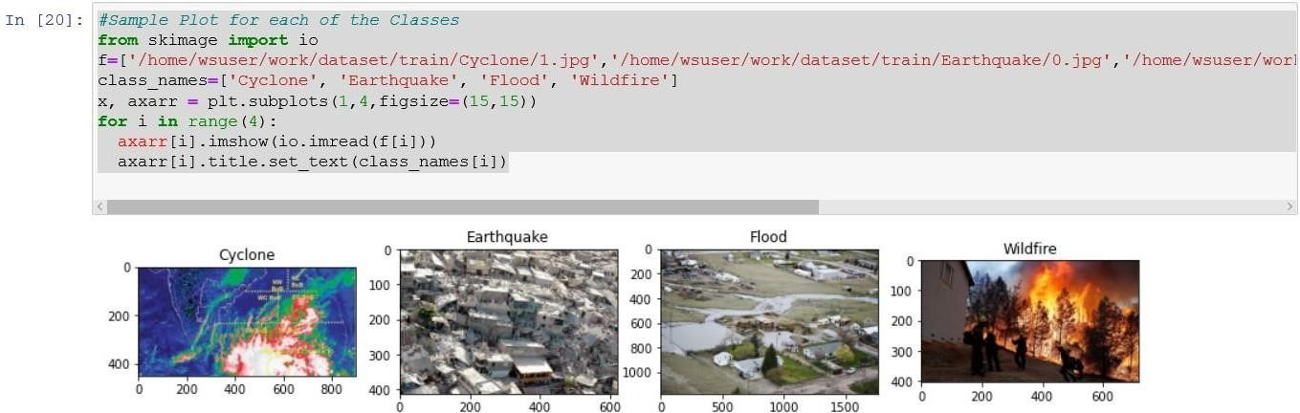

**3. CNN Model Architecture**

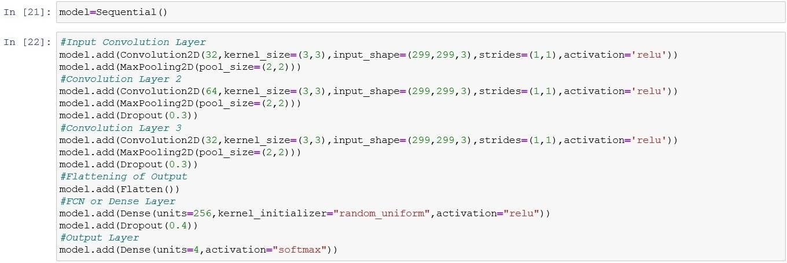

# 4. Summary of the Model

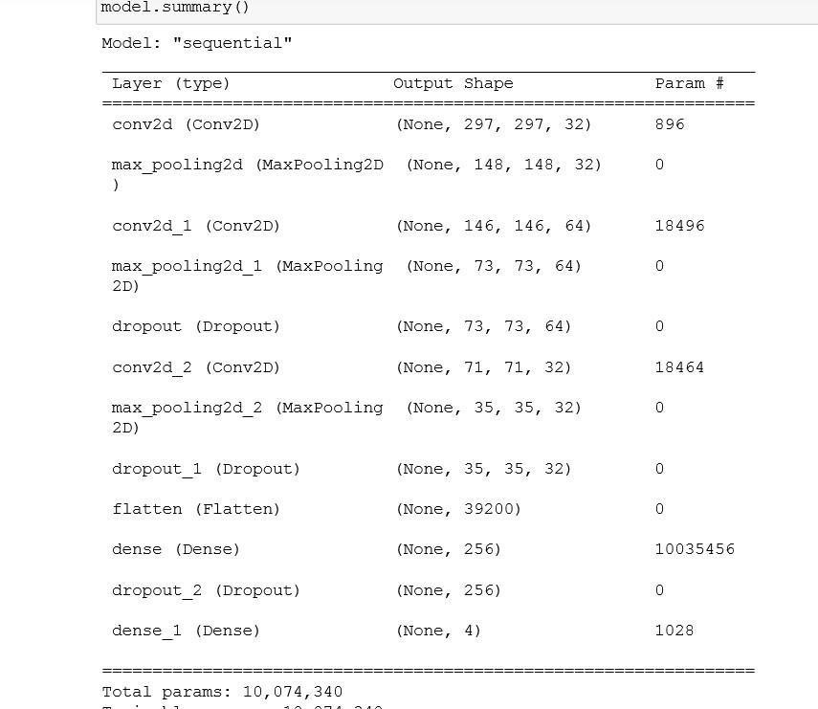

# 5. Compiling the Model



**6. Training and Validating the Model**

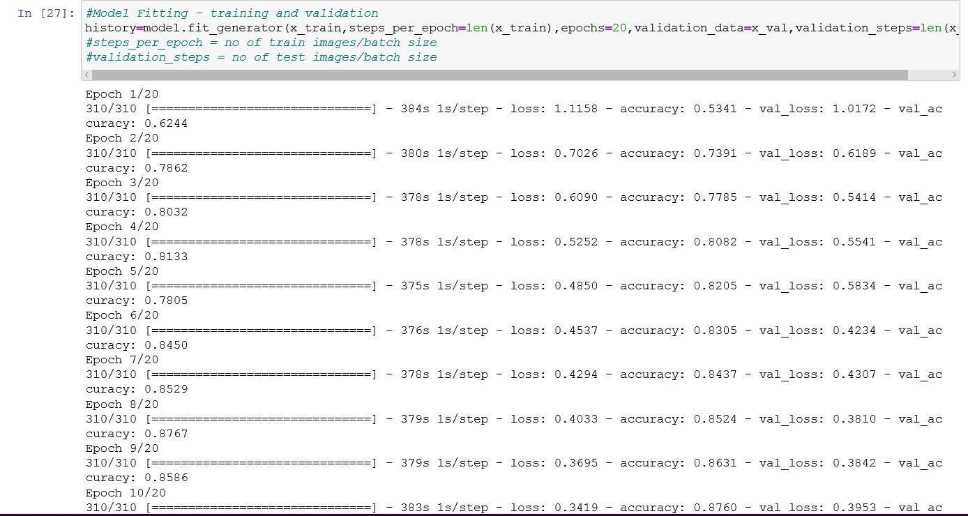

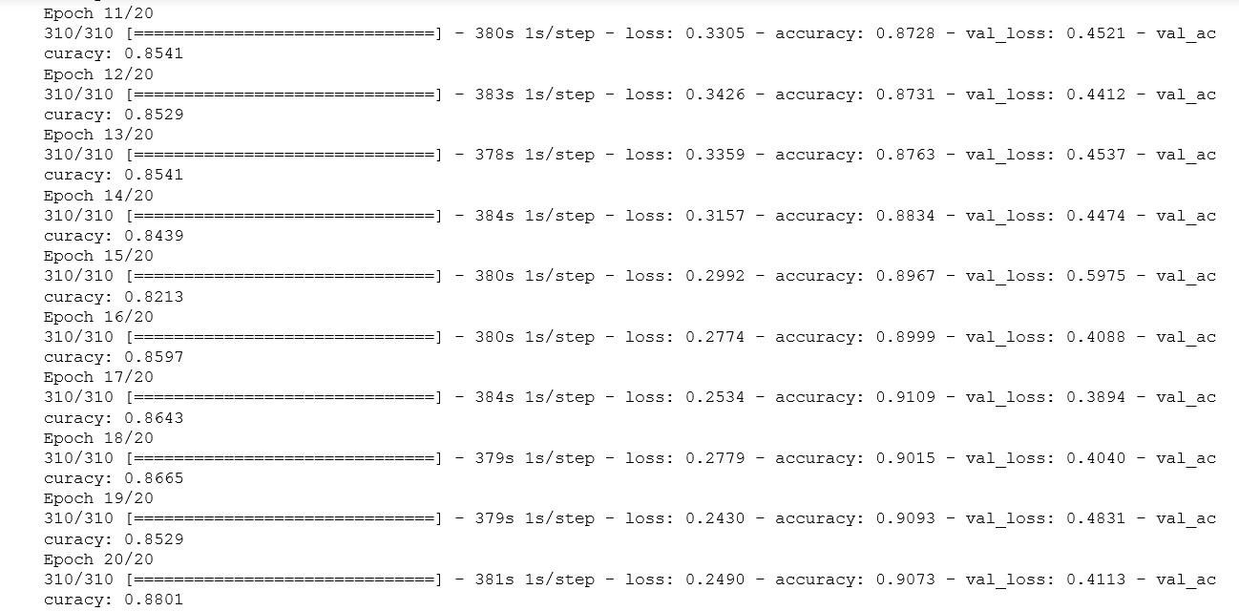

# 7. Saving the Model as .h5 file and json file

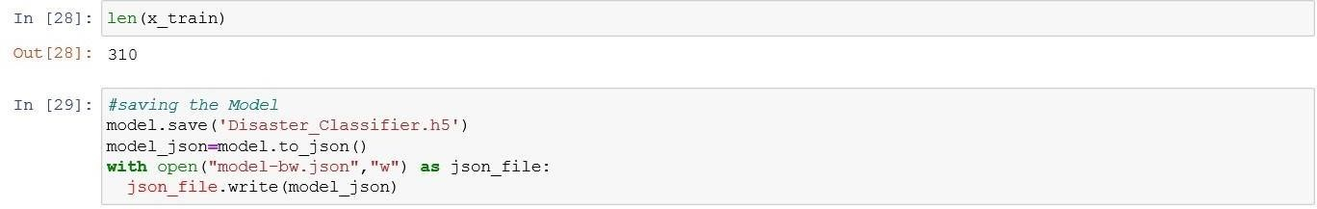

1. **Plots for training vs validation accuracies and losses**

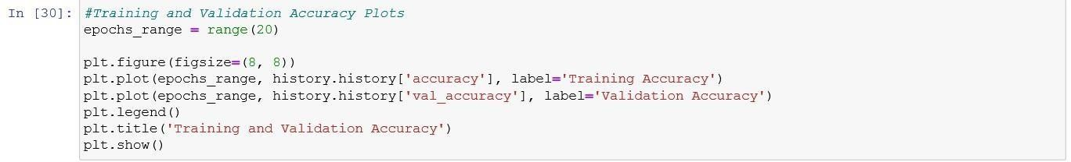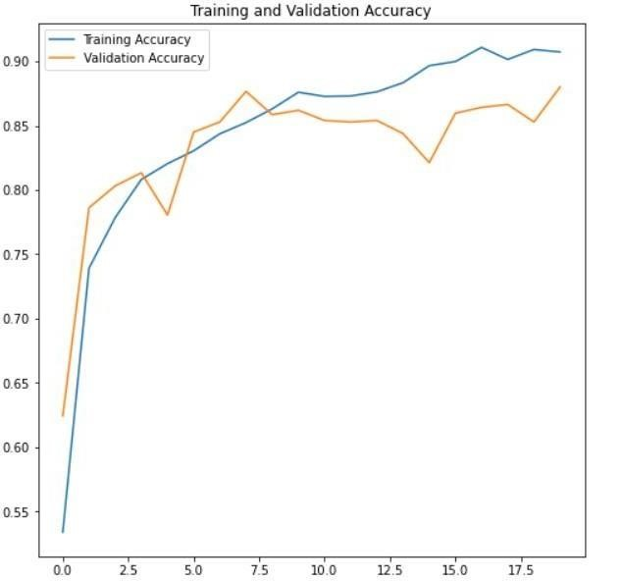

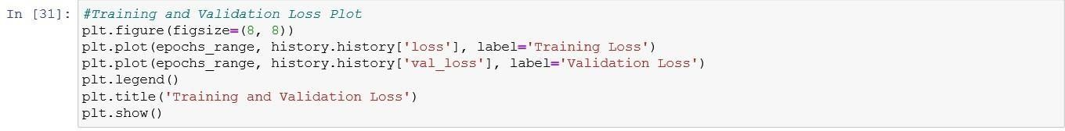

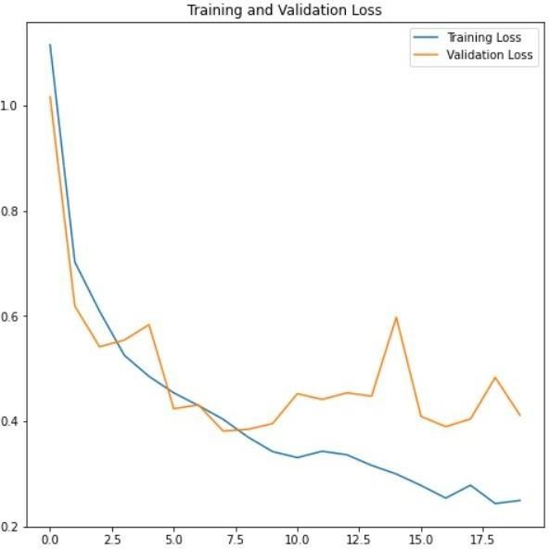

1. **Testing the CNN Model with test d**

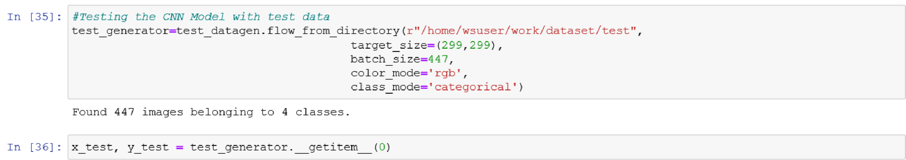

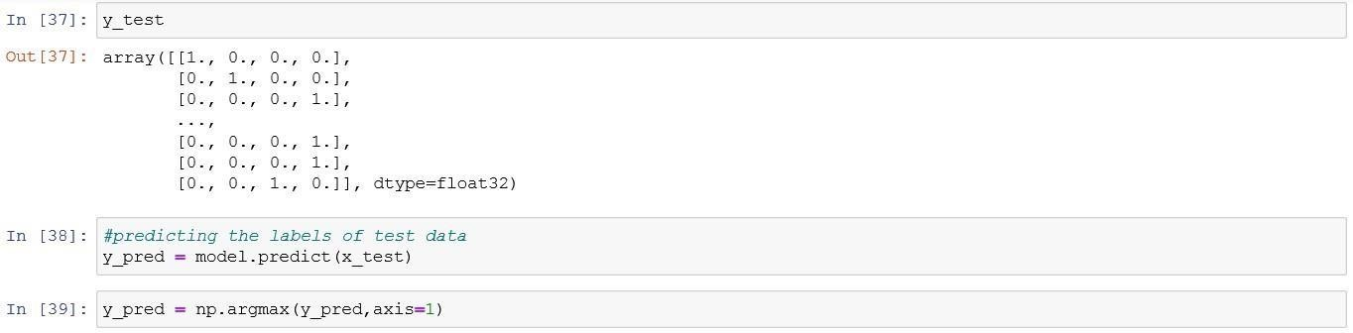

# ata

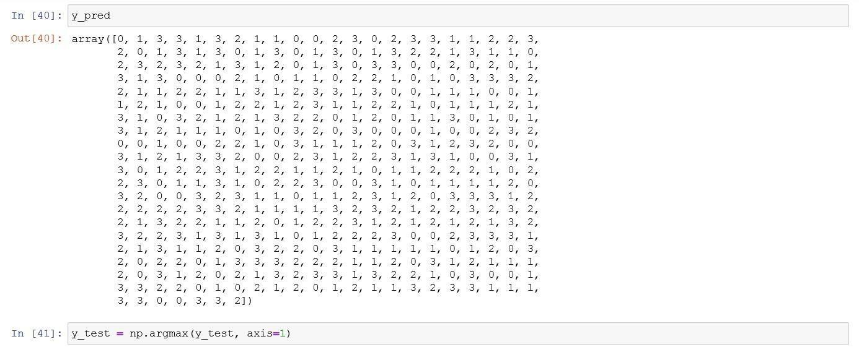

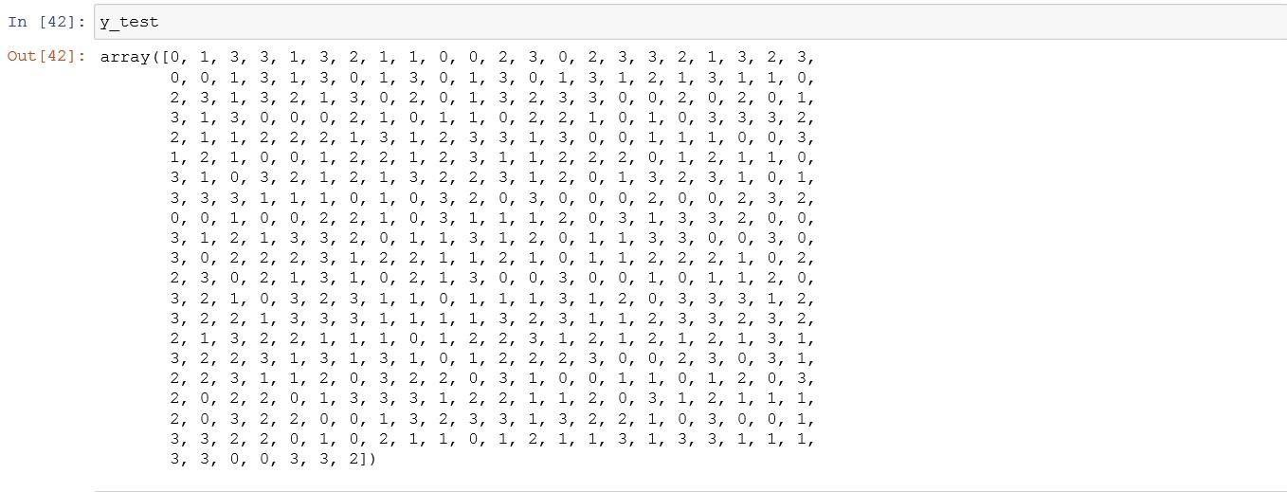

# 10. Generating Classification Report with F1 Score

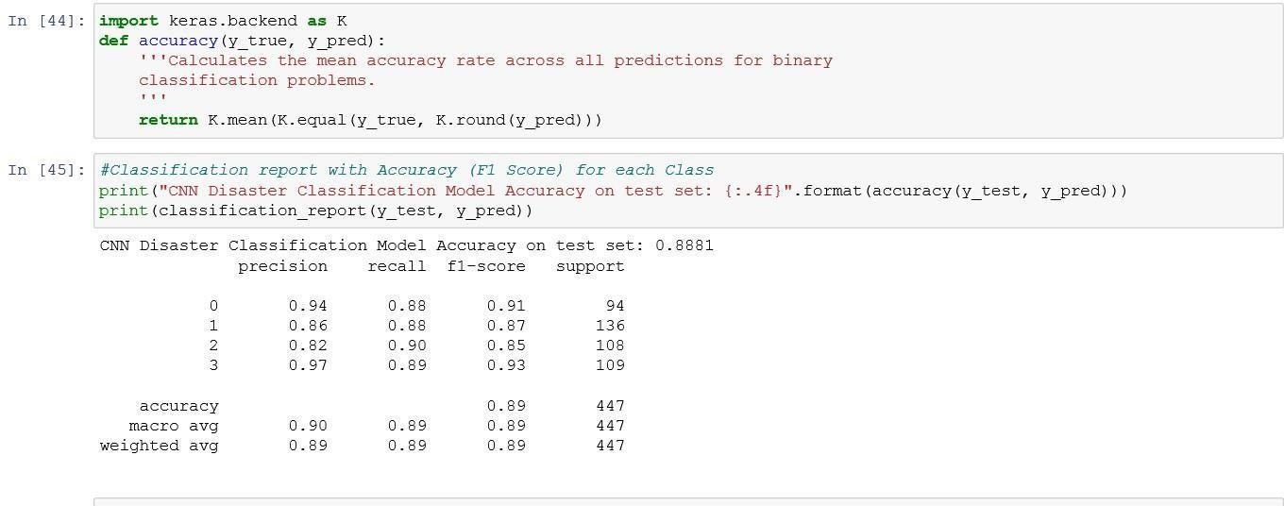

**11. Weighted Accuracy of the model**



# 12. Confusion Matrix for test data

